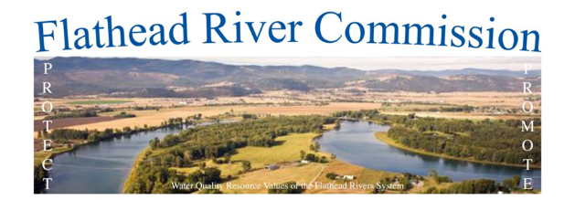

Flathead River Commission Minutes
April 12, 2017, 7:00pm, South Campus Building, 40 11th Street, West, 2nd Floor Conference Room

April Minutes
Attendees: Bob Storer, Verdell Jackson, Mark Haag, Pam Holmquist, Mark Siderius, Donna Pridmore, Steve Sekelsky, Roy Hutchins, Rusby Seabaugh, Kenny Breidinger
Absent: Cap Ingham, Larry Brosten, Gary Saurey
Public Attendees: Samantha Tappenbeck, Ada Montaque, Valerie Kurth

Intro & Public Comment: None
Minutes: Bob Storer moved to “approve March minutes”. Mark Haag seconded. Motion carried unanimously.
Old Business: Bob Storer gave an overview of the annual flood level meeting presented by Ray Nickless from the National Weather Service. There is an 80% chance of low level flooding when the Columbia Falls gage reaches 13’ and a 40% chance of low level flooding when the Columbia Falls gage reaches 14”. Today Hungry Horse Reservoir is 2’ higher than normal and Flathead Lake is 3’ higher than normal. Both dams are at maximum outflow. The low to middle snowpack has melted, but the snowpack in the higher elevation is 111% of normal. The current snowpack is at 112% of normal.
New Business: General discussion was held on spring runoff and the potential for flooding this spring.

Water compact: None
Adjournment: Steve Sekelsky moved “to adjourn”, Rusby Seabaugh seconded. Motion carried unanimously.

Minutes submitted by: Pam Holmquist

The next meeting is Monday, May 15, at 7pm, in the Earl Bennett Building, 1035 1st Ave. West, second floor conference room.

