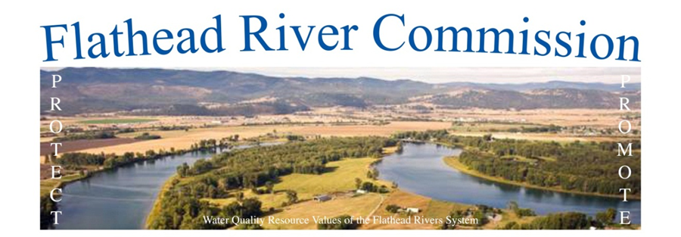

Photo by Gravity Shots

Flathead River Commission (FRC) Meeting
Monday, December 18, 2017, 7:00pm
South Campus Building, 40 11th Street West, 2nd Floor Conference Room

AGENDA

7:00pm CALL TO ORDER/INTRODUCTIONS

CHAIRMAN’S REMARKS:

PUBLIC COMMENT:

APPROVAL OF MINUTES:

November 20, 2017 Meeting

OLD BUSINESS:
Bob Storer: Moisture update

Verdell Jackson: Continue discussion of stabilization projects

Carl Glimm: Update on Montana Water Policy Interim Committee

NEW BUSINESS:

GENERAL DISCUSSION & NEXT STEPS

Rusby Seabaugh: Continue FRC next steps and discussion

2018 Officer Nominations

ADJOURN
Verdell Jackson 406-756-8344

